Training and Support portal – add an image

Go to your region’s portal:

Australia – [https://support.thomsonreuters.com.au](https://support.thomsonreuters.com.au/)

New Zealand – <https://support.thomsonreuters.co.nz>

Asia – <https://support.thomsonreuters.com.hk>

Korea – <https://support.thomsonreuters.com.kr>

MENA – <https://support.thomsonreuters.ae>

Click **Login** in the top-right, click **Premium Care Account**, and enter your username and password.

**Note:** if you don’t have a login for the Training and Support portal please contact Jessica FitzGerald.

# Add an image to your article/tip

All images on the Customer Portal need to be stored in the CMS library before you can add them to your article or tip. To add new media to the library, go to:

1. Content
2. Media
3. Add media
4. Choose Image from the drop-down menu.

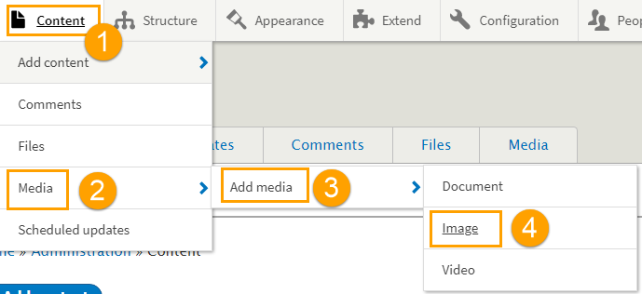

1. Uploading images
   1. File type: JPG/JPEG or PNG.

File size: less than 256 MB.

* 1. Naming convention: **[Region]-[Product]-[Content]-[Number or description]**, e.g.,
     1. NZ-newWLNZ-Tip-[image name]
     2. MENA-PLUK-Article-[image name]
     3. Asia-WLA-Article-[image name]

Avoid special characters, spaces, and underscores

**Note:** If you are creating a tip with multiple images/steps, include the number at the end, e.g., AU-newWLAU-Tip-DocumentAlert1

* 1. Click **Save** at the bottom of the screen.

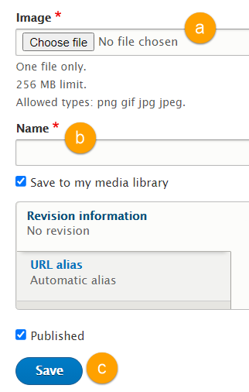

Create a new article/tip or edit your draft article/tip to include your image.

To edit a draft article/tip, find your article in the Content tab and click **Edit** (in the Operations column).

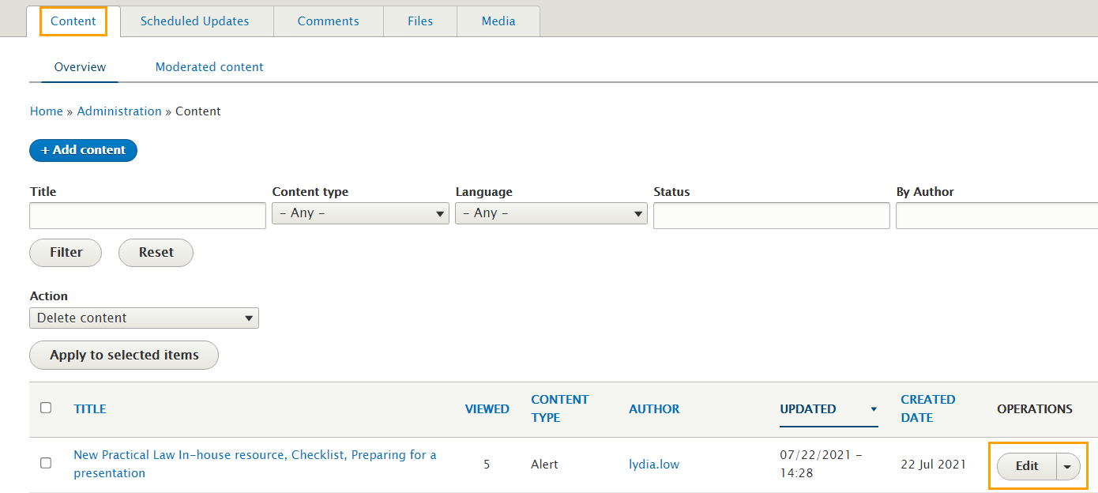

Go to **Paragraph Type** at the bottom of the screen, select **Image** from the drop-down menu, and click **Add Paragraph**.

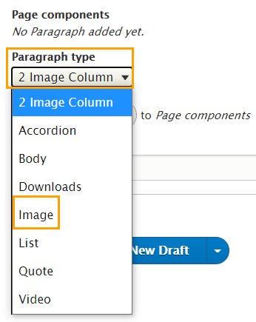

In the page component, click the **Select Image(s)** button.

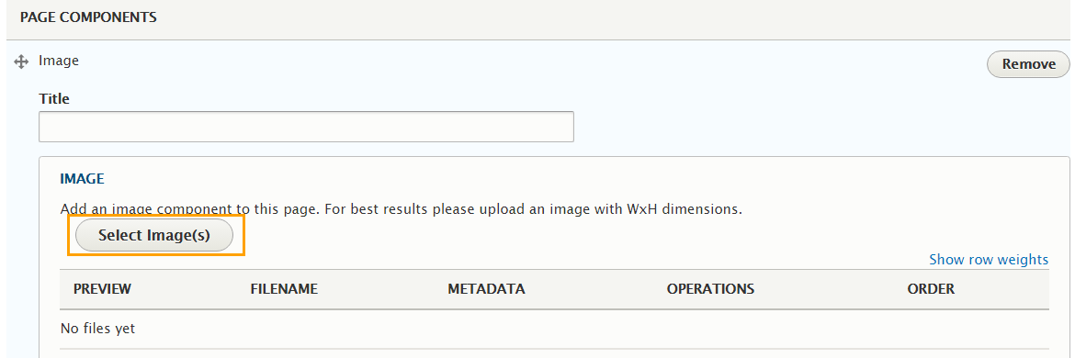

Choose your image, and click the blue **Select** button at the bottom the pop-up window.

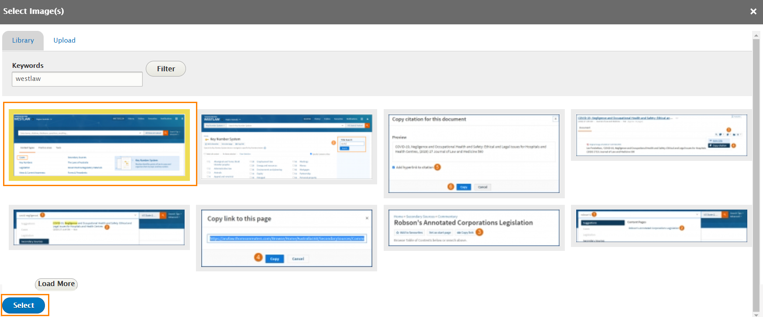

You can leave the title and caption blank.

Finalise your text by adding another Page Component > Body, then either publish or save as a draft.

Your final article/tip with an image between two sections of text should look like the following:

